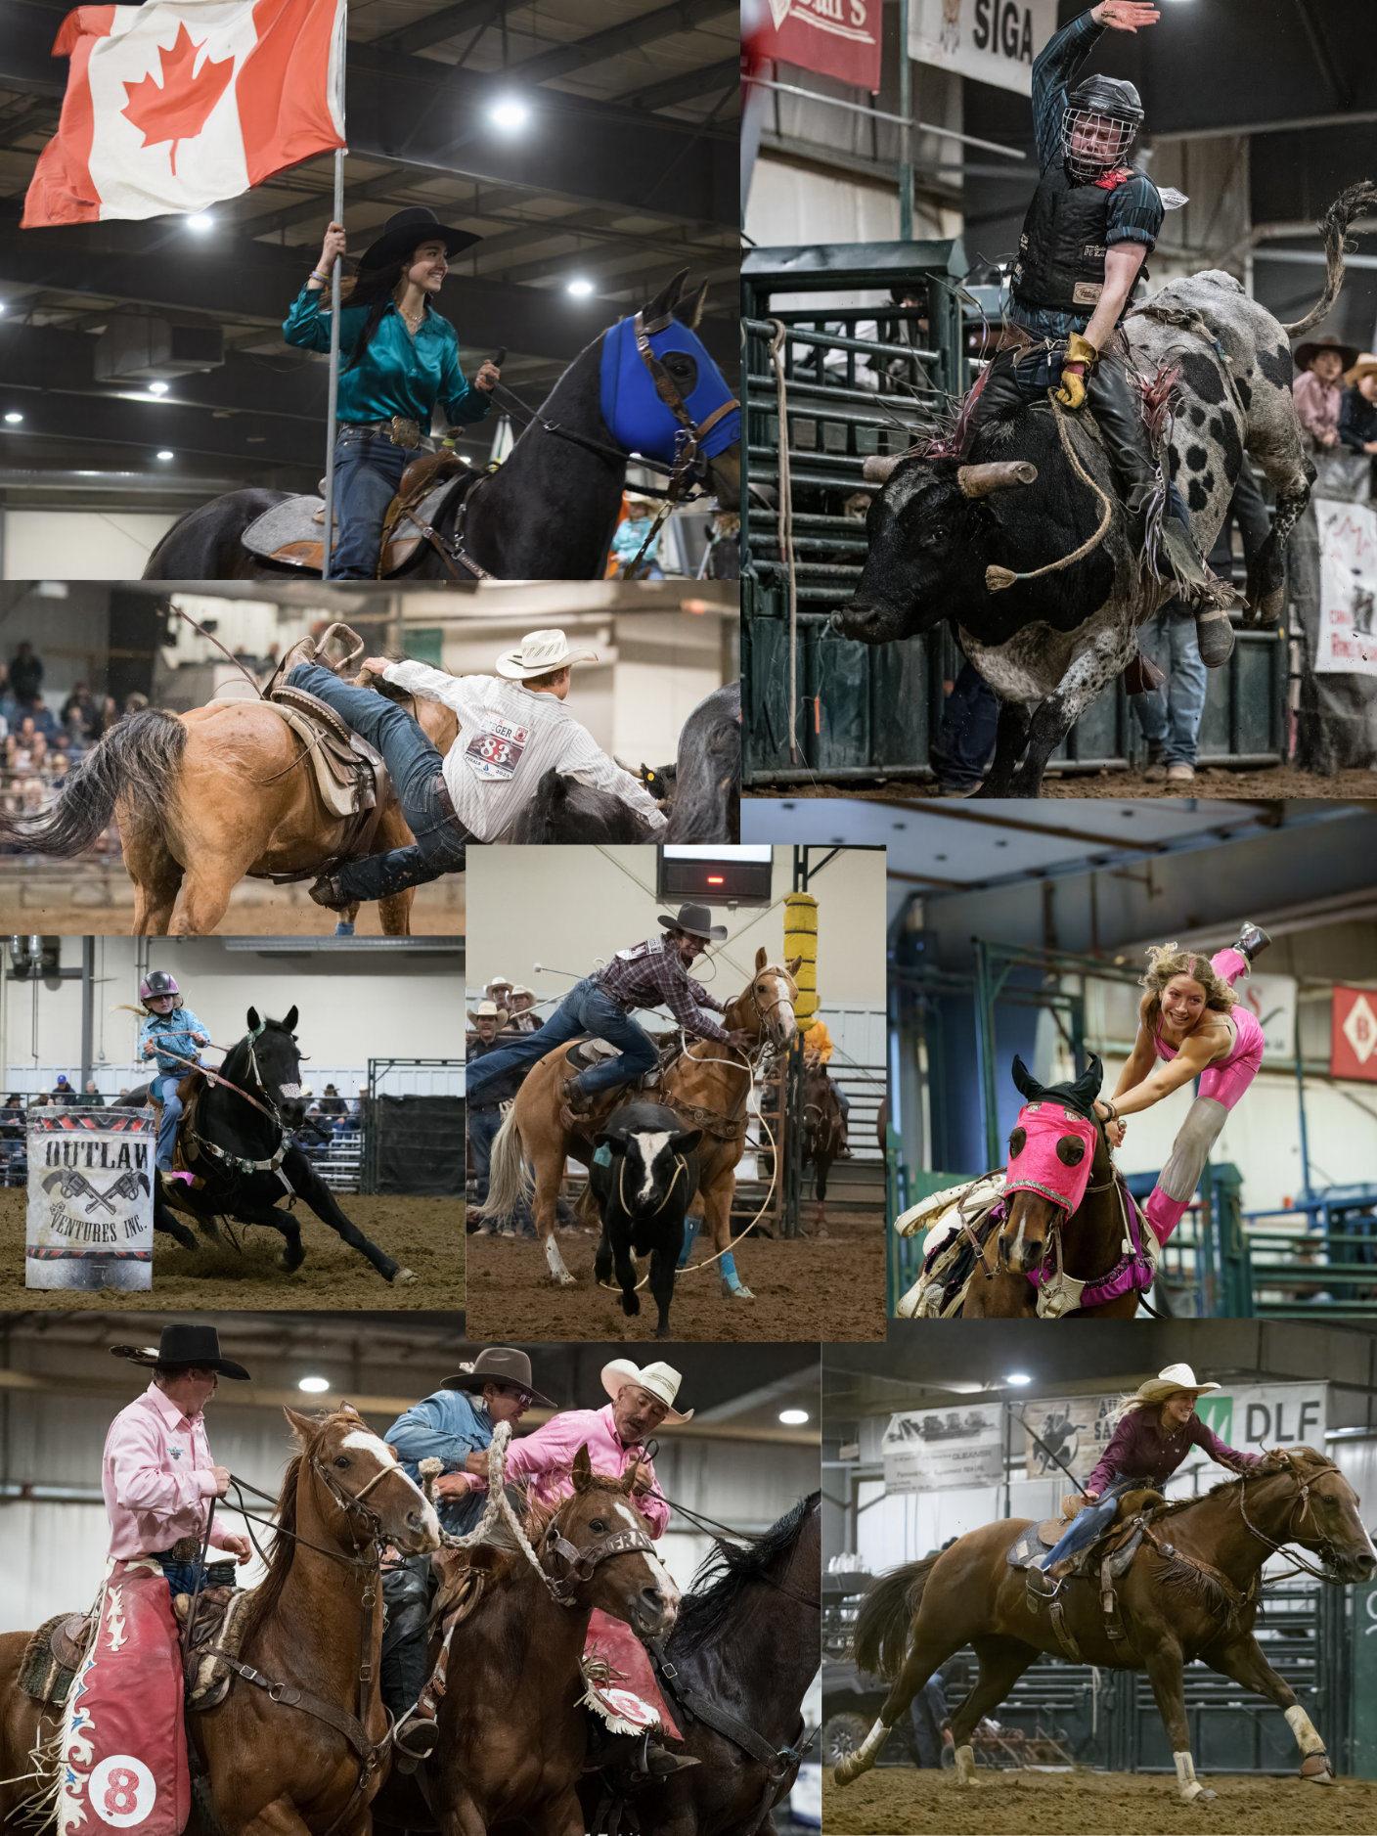
Kakeyow Cowboys Rodeo Association Sponsorship Package 2024
Kakeyow Cowboys Rodeo Association
The Kakeyow Cowboys Rodeo Association (KCRA) was established in 1999 and is a one-of-a-kind, family-orientated organization. We provide opportunities for youth to learn and sharpen their rodeo skills in a safe, fun, friendly, and family-oriented atmosphere that encourages character, respect, and diligence while promoting the sport of rodeo.
Kakeyow means “all together.” The KCRA allows families to remain “all together” by providing events for age groups from peewee to retirement.
This year we will be celebrating our 25th anniversary!
Our season consists of rodeos based in Saskatchewan which regularly bring in between 300 and 400 entries per day. The season culminates with the Finals Rodeo in the fall at Prairieland Park in Saskatoon.
You can learn more about our association on our website www.kcrarodeo.com or our Facebook page “Kakeyow Cowboys Rodeo Association.”
Advertising With Us
As a sponsor, you are becoming part of a tradition that helps maintain rural roots and a small-town community culture. You are investing in the future of rodeo, ensuring our youth have the resources to achieve their dreams.
The KCRA is extremely grateful for our sponsors, and we go the extra mile to ensure our sponsors receive valuable exposure to each community to which we bring our association. When you become a sponsor, you allow the KCRA to successfully present events annually that give back through entertainment, economic, and tourism benefits to each community.
Sponsorships are available with the KCRA in several ways and can fit into all sizes of budgets, creating a powerful marketing partnership. Sponsorship provides excellent exposure to your company’s products and services, increasing awareness and traffic to your company or business in return.
The KCRA offers several sponsorship packages. Details about each option can be found in the following pages.
If you have any questions, or to commit to sponsorship for the 2024 season, please contact any member of the KCRA Board of Directors. We look forward to hearing from you and thank you for your time.
Sincerely,
The KCRA Board of Directors

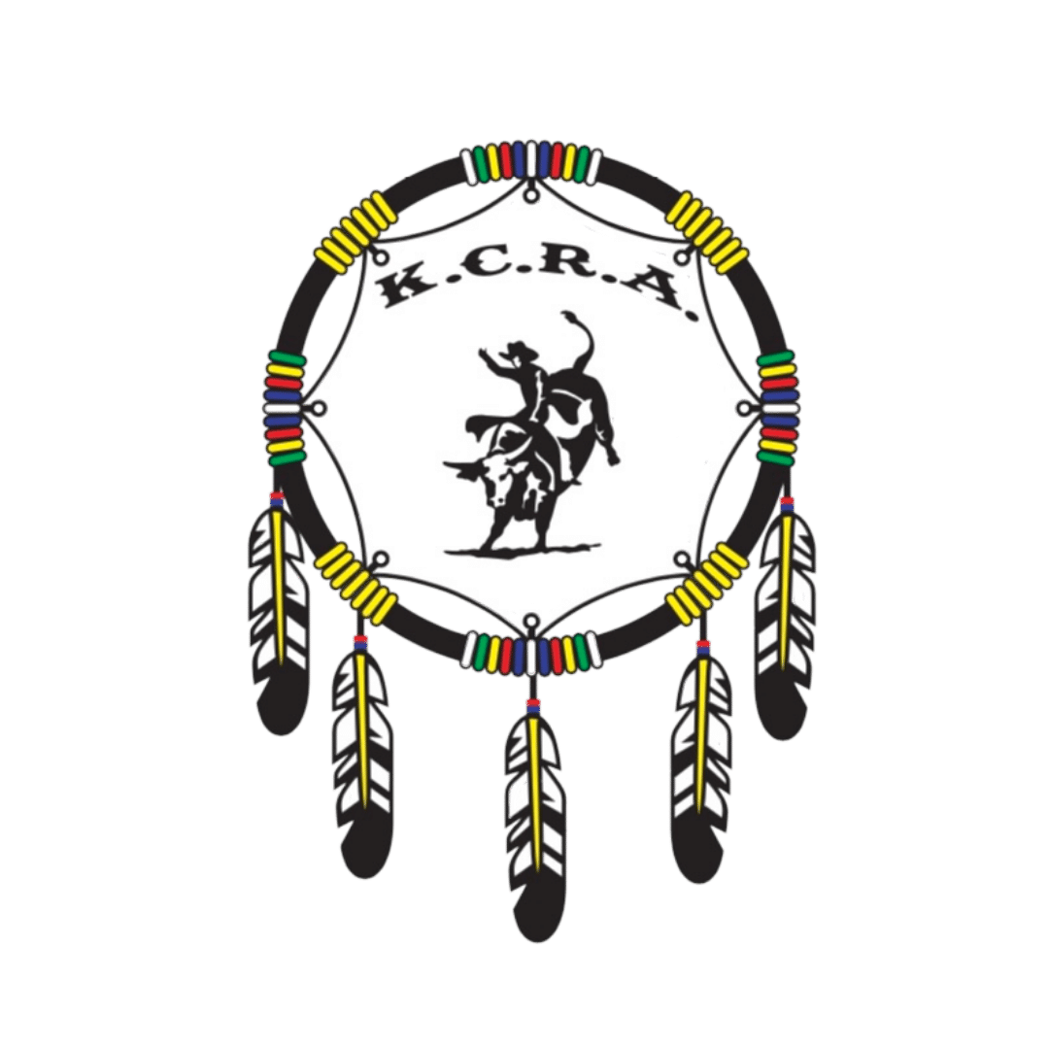
Letter of Commitment
Major Corporate Partner
$5,000 +
The Major Corporate Partner package gives your business an opportunity to become a valued partner for all KCRA Rodeos for the 2024 season, including the Finals.
With this opportunity, we will work with you to build a package that meets the objectives of the KCRA and your advertising needs. Some of the advertising you can expect are listed below.
Please note payments must be received by June 1, 2024, to guarantee your name on apparel and any promotional publications.

Guaranteed Advertising Coverage:
- Professional banner displayed and a flag flown at each KCRA Rodeo and the Finals. Banner and flag to be provided by the sponsor.
- Logo on all association coats.
- Full-page ad space with product and service information in the Finals program.
- Detailed announcement spots at all Finals performances.
- Passes to each of the Finals performances.
- Social media coverage on our official Facebook account.
Name of Sponsor: ______________________________________________________________
Address: ______________________________________________________________________
Phone: __________________________________ Email: ________________________________
Advertisement Requests: _________________________________________________________
Amount of Investment Commitment: $______________________________________________
Signature: _______________________________________________Date__________________
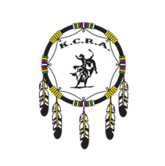
Letter of Commitment
Personnel Apparel or Leader Board Business Advertising Partnership
$3,000
With this package, your brand will be in the rodeo arena all season. Our judges, pick-up men, and bullfighters spend countless hours in the arena supporting our cowboys and cowgirls. Our leaderboard is referred to regularly. This is a steal of a deal for prospective investors.
Please note payments must be received by June 1, 2024, to guarantee your name on apparel and any promotional publications.
Choose of one of the following (please select your preference):
Judges ______ Pick Up Men ______ Bull Fighters ______ Leader Board _____
Advertising Coverage:
- Personalized logo being worn by your above choice during the regular rodeo season and Finals.
- Logo on all association coats.
- Company/business name listed in the official finals program.
- Detailed announcement spots at all Finals performances.
- Company/business name displayed on KCRA website with links.
- Day passes to the Finals.
- Social media coverage on our official Facebook account.
Name of Sponsor: ______________________________________________________________
Address: ______________________________________________________________________
Phone: __________________________________ Email: ________________________________
Advertisement Requests: _________________________________________________________
Amount of Investment Commitment: $______________________________________________
Signature:_________________________________________ Date________________________
Letter of Commitment
Saddle Sponsor Advertising Partnership
$2,000 – Limited Number Available!
Trophy saddles are awarded to our High Point Champions. With this package, your sponsorship will be recognized throughout the Finals and for years to come as part of the recipient’s continued use of this cherished prize, both in and out of the rodeo arena.
Please note payments must be received by June 1, 2024, to guarantee your name on apparel and any promotional publications.
Saddle: Senior High Point _______ Junior High Point _______ Queen _______
Advertising Coverage:
- Sponsor name stamped on the saddle.
- Sponsor recognition with the presentation at Finals.
- Sponsor name listed on the sponsorship page in the Finals program.
- Banner displayed at Finals, to be provided by the sponsor.
- Company or business name displayed on KCRA website.
- Weekend passes to the Finals.
- Social media coverage on our official Facebook account.
Name of Sponsor: ______________________________________________________________
Address: ______________________________________________________________________
Phone: __________________________________ Email: ________________________________
Advertisement Requests: _________________________________________________________
Amount of Investment Commitment: $______________________________________________
Signature:___________________________________________Date_______________________

Letter of Commitment
Finals Back Numbers Advertising Partnership
$2,000
This opportunity allows your company or business name to be visible throughout the entire Finals. Every finalist is provided a back number and will be wearing the numbers throughout the event. This exposure continues into the stalling area and trailer parking as contestants spend their time outside of the arena in these areas.
Please note payments must be received by June 1, 2024, to guarantee your name on apparel and any promotional publications.
Advertising Coverage:
- Banner displayed during the Finals, to be provided by the sponsor.
- Sponsor name listed on the back numbers of all Finals contestants.
- Back number sponsor recognition with presentation opportunity.
- Recognition announcement spots throughout all Finals performances.
- Sponsor name listed on the sponsorship page in the official Finals program.
- Company or business name displayed on KCRA website.
- Weekend passes to the Finals.
- Social media coverage on our official Facebook account.

Name of Sponsor: ______________________________________________________________
Address: ______________________________________________________________________
Phone: __________________________________ Email: ________________________________
Advertisement Requests: _________________________________________________________
Amount of Investment Commitment: $______________________________________________
Signature:
________________________________________________Date_________________________

Letter of Commitment
“Best Buy” Finals Announcer Advertising Partnership
$2,000
This opportunity allows your contribution to be recognized throughout the entire Finals. The announcer is a vital part of tying the rodeo performance together. He provides critical information about each event, as well as exciting and knowledgeable commentary of each ride, run, contestant, rodeo stock, and personnel. His knowledge of the sport of rodeo allows non-rodeo spectators to learn more about the western way of life while enjoying the action. With this package, your company or business name will become part of the announcer’s energetic and memorable rodeo commentary.
Please note payments must be received by June 1, 2024, to guarantee your name on apparel and any promotional publications.
Advertising Coverage:
- Banner displayed during the Finals, to be provided by the sponsor.
- Recognition announcement spots throughout all 4 Finals performances.
- Sponsor name listed on the sponsorship page in the official Finals program.
- Company or business name displayed on KCRA website.
- Weekend passes to the Finals.
- Social media coverage on our official Facebook account.

Name of Sponsor: ______________________________________________________________
Address: ______________________________________________________________________
Phone: __________________________________ Email: ________________________________
Advertisement Requests: _________________________________________________________
Amount of Investment Commitment: $______________________________________________
Signature: ________________________________________ Date_________________________

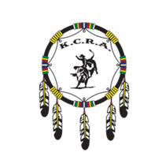
Letter of Commitment
“Premium” Finals Advertising Partnership: Bucking Chute or Timed Event Gate
$1,000
This package allows our sponsors an elite opportunity to be recognized in the arena throughout the Finals. The chutes and timed events gates are visible and often the center of attention as the cowboys and cowgirls prepare to compete.
Please note payments must be received by June 1, 2024, to guarantee your name on apparel and any promotional publications.
Sponsorship Choice: Bucking Chute ______ Timed Event Gate ______
Advertising Coverage:
- Banner displayed in the arena during Finals, to be provided by the sponsor.
- Recognition announcement spots throughout all Finals performances.
- Sponsor name listed on the sponsorship page in the official Finals program.
- Company/business name displayed on KCRA website.
- Weekend passes to the Finals.
- Social media coverage on our official Facebook account.
Name of Sponsor: ______________________________________________________________
Address: ______________________________________________________________________
Phone: __________________________________ Email: ________________________________
Advertisement Requests: _________________________________________________________
Amount of Investment Commitment: $______________________________________________
Signature: __________________________________________ Date_______________________

Letter of Commitment
Finals Advertising Partnership: Pickup Men or Bullfighters Buckles
$1,000
Our Pick-Up Men and Bullfighters are integral to the success of the contestants and livestock. They work diligently to keep everyone safe and, in many cases, put their life on the line for all of our rough stock event athletes. In order to be part of our finals, these men and women are voted on by the contestants and earn their spots at the Finals.
Sponsorship Choice: Pick Up Men Buckles _______ Bullfighters Buckles ________
Advertising Coverage:
- Banner displayed in the arena during Finals, to be provided by the sponsor.
- Recognition announcement spots throughout all Finals performances.
- Sponsor name listed on the sponsorship page in the official finals program.
- Company/business name displayed on KCRA website.
- Passes to the Finals.
- Social media coverage on our official Facebook account.
Name of Sponsor: ______________________________________________________________
Address: ______________________________________________________________________
Phone: __________________________________ Email: ________________________________
Advertisement Requests: _________________________________________________________
Amount of Investment Commitment: $______________________________________________
Signature: ________________________________________Date_________________________

Letter of Commitment
Finals Event Sponsorship Year End Buckles & Finals Champion Buckles
$500 for one buckle OR $1,000 for both buckles and event title
The KCRA has 17 events at each rodeo and the finals. At the end of each year, the rodeo athlete with the most points in the season is presented with a Season Leader trophy buckle. After the conclusion of the Finals, the rodeo athlete with the most points in the finals is presented with a Championship trophy buckle.
Trophy buckles are a part of cowboy attire and are highly regarded within western culture. Contestants wear these proudly day in and day out. With this package, you can be guaranteed your brand will be noticed for years to come. All buckles are presented to the season leaders and champions at the Finals with sponsorship recognition.
Advertising Coverage ($500 package):
- Season Leader or Finals Champion trophy buckle sponsorship of your chosen event, with recognition during the awards ceremony at the Finals.
- Recognition announcement spots throughout all Finals performances.
- Sponsor name listed on the sponsorship page in the official Finals program.
- Company/business name displayed on KCRA website.
- Day passes to the Finals.
Advertising Coverage ($1,000 package):
- Title sponsor of the chosen event for every rodeo throughout the entire season (for example, the Canadian Horses to Move Ladies Breakaway Roping).
- Season Leader and Finals Champion trophy buckle sponsorship of your chosen event, with recognition during the awards ceremonies at the Finals.
- Recognition announcement spots throughout all Finals performances.
- Sponsor name listed on the sponsorship page in the official Finals program.
- Company/business name displayed on KCRA website.
- Passes to the Finals.

Please select and initial your primary event sponsorship choice:
Senior Events | Season Leader | Finals Champion
Bareback Riding
Tie Down Roping
Saddle Bronc Riding
Steer Wrestling
Ladies Breakaway Roping
Team Roping Header
Team Roping Heeler
Ladies Barrel Racing
Bull Riding

Junior Events | Season Leader | Finals Champion
Steer Riding
Breakaway Roping
Team Roping
Barrel Racing

PeeWee Events | Season Leader | Finals Champion
Steer Riding
PeeWee Breakaway Roping
Team Roping
Barrel Racing

Name of Sponsor: ______________________________________________________________
Address: ______________________________________________________________________
Phone: __________________________________ Email: ________________________________
Advertisement Requests: _________________________________________________________
Amount of Investment Commitment: $______________________________________________
Signature: __________________________________________ Date______________________

Letter of Commitment
Horse of the Year Advertising Partnership – Limited Number Available!
$500
The prestigious Horse of the Year Award is recognized in all areas of rodeo life. Voted on by the Finals qualifiers, the Horse of the Year is an animal athlete that displays incredible talent and athleticism throughout the rodeo season and helps the cowboy or cowgirl do their job well.
By investing in this package, your brand will be displayed every time that horse wears the blanket. This will continue beyond regular rodeo seasons and for years to come.
Please note payments must be received by June 1, 2024, to guarantee your name on apparel and any promotional publications.
Advertising Coverage:
- Your company/business on the trophy blanket.
- Blanket sponsor recognition with presentation opportunity.
- Recognition announcement spots throughout all Finals performances.
- Sponsor name listed on the sponsorship page in the official finals program.
- Company/business name displayed on KCRA website.
- Complimentary passes to the Finals.
Blanket:
- Ladies Barrel Racing ____
- Junior Barrel Racing ____
- PeeWee Barrel Racing ____
- Steer Wrestling ____
- Hazing ____
- Team Roping Header ____
- Team Roping Heeler ____
- Junior Team Roping ____
- PeeWee Team Roping ____
- Ladies Breakaway Roping ____
- Junior Breakaway Roping ____
- PeeWee Breakaway Roping ____
- Tie Down Roping ____
Name of Sponsor: ______________________________________________________________
Address: ______________________________________________________________________
Phone: __________________________________ Email: ________________________________
Advertisement Requests: _________________________________________________________
Amount of Investment Commitment: $______________________________________________
Signature:
________________________________________________Date_________________________

